**CHAPTER 3**

**COMPUTER ASSEMBLY—STEP BY STEP**

**Objectives**

Upon completion of this chapter, you should be able to answer the following questions:

n

How do I open the case?

n

What is the process to install the power supply?

n

How

do I attach the components to the

motherboard and install the motherboard?

n

How

do I install internal drives?

n

How do I install drives in external bays?

n

How do I install adapter cards?

n

What is the process to connect all internal

cables?

n

How

do I reattach the side panels and connect

external cables to the computer?

n

What happens when I boot the computer for the

first time?

**Key Terms**

This chapter uses the following key terms. You can find the definitions in the Glossary.

*electrostatic discharge*

*(*

*ESD*

*)*

*page*

*80*

*power supply*

*page 80*

*page 81*

*motherboard*

*central processing unit (CPU)*

*page 82*

*zero insertion force (ZIF) socket*

*page 83*

*thermal compound*

*page 83*

*isopropyl alcohol*

*page 83*

*heat sink/fan assembly*

*page 83*

*random-access memory (RAM)*

*page 83*

*volatile memory*

*page 85*

*hard*

*disk drive (HDD)[em]page*

*86*

*optical drive*

*page 86*

*floppy disk drive (FDD)*

*page 86*

*Molex*

*power connector*

*page*

*86*

*Berg*

*power connector*

*page*

*87*

*page 88*

*adapter card*

*page 88*

*network interface card (NIC)*

*video adapter card*

*page*

*89*

*Advanced Technology Extended (ATX)*

*page 91*

*Serial Advanced Technology Attachment (SATA)*

*power connector*

*page 91*

*Parallel Advanced Technology Attachment (PATA)*

*Data cable*

*page 92*

*Serial Advanced Technology Attachment (SATA) data*

*page*

*cable*

*92*

*basic input/output system (BIOS)[em]page 96*

*beep code*

*page 97*

*complementary metal-oxide semiconductor (CMOS)*

*page 97*

79

.qxp 8/20/10 1:37 PM Page

9781587132636_ch03

Assembling computers is a large part of a technician’s job. As a technician, you will need to

work in a logical, methodical manner when working with computer components. As with

any learned trade, your computer assembly skills will improve dramatically with practice.

**Open the Case**

Computer cases are produced in a variety of form factors. Form factors refer to the size and

shape of the case.

Prepare the workspace before opening the computer case. There should be adequate light-

ing, good ventilation, and a comfortable room temperature. The workbench or table should

be accessible from all sides. Avoid cluttering the surface of the workbench or table with

tools and computer components. An antistatic mat on the table will help prevent physical

and

***electrostatic discharge(ESD)***

damage to equipment. Small containers can be used to

hold small screws and other parts as they

are being removed.

There are different methods for opening cases. To learn how to open a particular computer

case, consult the user manual or the manufacturer’s website. Most computer cases are

opened in one of the following ways:

n

The computer case cover can be removed as one piece.

n

The top and side panels of the case can be removed.

n

The top of the case may need to be removed before the side panels can be removed.

n

Tool-less entries allow

technicians to enter a case without the use of tools.

**Install the Power Supply**

A

technician may be required to replace or install a power supply, as shown in Figure 3-1.

Most

***power supplies***

can fit into the computer case in only one way.

There are usually three

or four screws that attach the power supply to the case. Power supplies have fans that can

vibrate and loosen screws that are not secured. When installing a power supply,

make sure

that all of the screws are used and that they are properly tightened.

These are the power supply installation steps:

**Step 1.**

Insert the power supply into the case.

**Step 2.**

Align the holes in the power supply with the holes in the case.

**Step 3.**

Secure the power supply to the case using the proper screws.

80

**How To**

**Figure 3-1**

Power Supply

Chapter 3: Computer Assembly—Step by Step

81

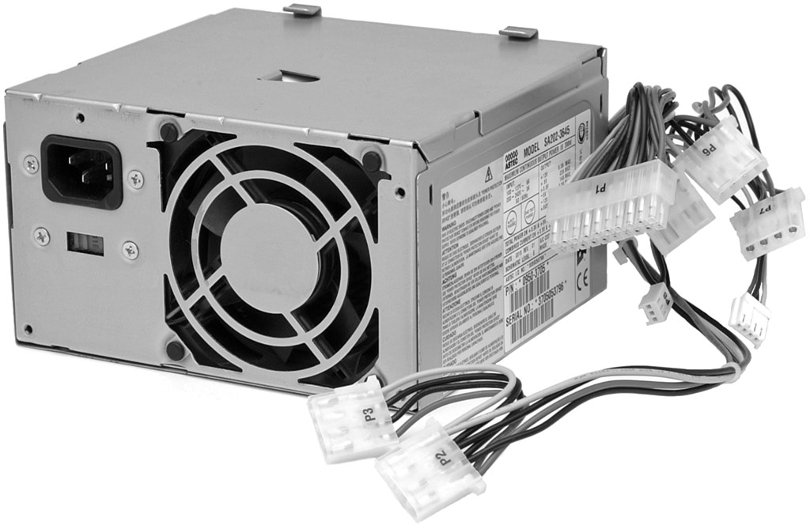

**Virtual Desktop Activity: Power Supply**

Complete the power supply layer in the Virtual Desktop. Refer to the Virtual Desktop soft-

ware on the CD that comes with this book.

**Virtual Desktop Activity: Motherboard**

System requirements for the Virtual Desktop include a minimum of 512 MB RAM and

Windows 2000 or Windows XP operating system.

**Lab 3.2.0: Install the Power Supply**

In this lab, you install the power supply in the computer.

Refer to the lab in

*IT Essentials:*

*PC Hardware and Software Lab Manual, Fourth Edition*

.You may perform this lab now or

wait until the end of the chapter.

**Attach the Components to the Motherboard**

**and Install the Motherboard**

This section details the steps to install components on the

***motherboard***

and then install the

motherboard into the computer case.

After completing this section, you will meet these objectives:

n

Install a CPU and a heat sink/fan assembly.

n

Install the RAM.

n

Install the motherboard.



**Install a CPU and a Heat Sink/Fan Assembly**

The

***central processing unit (CPU)***

and the heat sink/fan assembly may be installed on the

motherboard before the motherboard is placed in the computer case.

CPU

Figure 3-2 shows a close-up view of the CPU and the motherboard. The CPU and mother-

board are sensitive to electrostatic discharge. When handling a CPU and motherboard, make

sure that you place them on a grounded antistatic mat. You should wear an antistatic wrist

strap while working with these components. Key electrostatic-sensitive components include

the following:

n

CPUs

n

Motherboards

n

RAM

n

Expansion cards

n

Hard disk drive electronics

**Figure 3-2**

CPU and Motherboard

82

IT Essentials: PC Hardware and Software Companion Guide

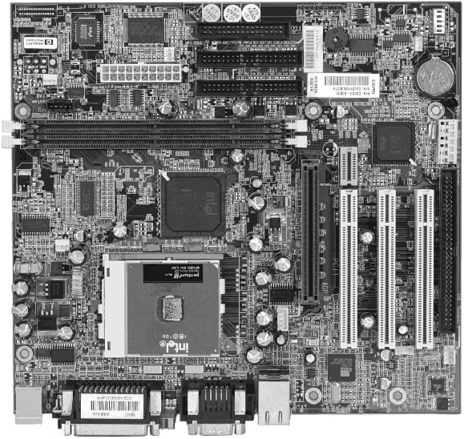

**Caution**

When handling a CPU, do not touch the CPU contacts at any time.

The CPU is secured to the socket on the motherboard with a locking assembly. The CPU

sockets today are

***zero insertion force (ZIF) sockets***

.

You should be familiar with the lock-

ing assembly before attempting to install a CPU into the socket on the motherboard. Orient

the missing pin in the corner of the CPU to the missing hole on the socket.

***Thermal compound***

helps to conduct heat away from the CPU. Figure 3-3 shows thermal

compound being applied to the CPU.

**Figure 3-3**

Thermal Compound on the CPU

Chapter 3: Computer Assembly—Step by Step

83

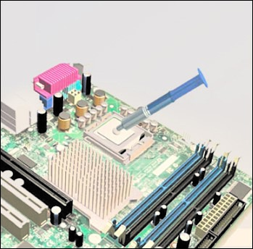

**Caution**

Silver-oxide thermal compound is toxic. Use rubber gloves and wash your hands thoroughly after-

ward. It does not takevery much compound to f

ill the space between the CPU and heat sink. If you

use too much it will leak onto the motherboard.

When you are installing a used CPU, clean the CPU and the base of the heat sink with

***isopropyl alcohol***

.

Doing this removes all traces of old thermal compound. The surfaces are

now ready for a new layer of thermal compound. Follow all manufacturer recommendations

about applying the thermal compound.

Heat Sink/Fan Assembly

Figure3-4 shows the connector and the motherboard header for the

***heat sink/fanassembly***

.

It is a two-part cooling device. The heat sink draws heat away from the CPU. The fan

moves the heat away from the heat sink. The heat sink/fan assembly usually has a 3-pin

power connector.

**Figure 3-4**

Heat Sink/Fan Assembly on the Motherboard

84

IT Essentials: PC Hardware and Software Companion Guide

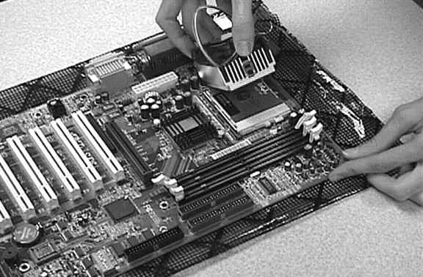

Follow these instructions for CPU and heat sink/fan assembly installation:

**Step 1.**

Align the CPU so that the Connection 1 indicator is lined up with Pin 1 on the

CPU socket. Doing this ensures that the orientation notches on the CPU are

aligned with the orientation keys on the CPU socket.

**Step 2.**

Place the CPU gently into the socket.

**Step 3.**

Close the CPU load plate and secure it in place by closing the load lever and

moving it under the load lever retention tab.

**Step 4.**

Apply a small amount of thermal compound to the CPU and spread it evenly.

Follow the application instructions provided by the manufacturer.

**Step 5.**

Align the heat sink/fan assembly retainers with the holes on the motherboard.

**Step 6.**

Place the heat sink/fan assembly onto the CPU socket, being careful not to pinch

the CPU fan wires.

**Step 7.**

Tighten the heat sink/fan assembly retainers to secure the assembly in place.

**Step 8.**

Connect the heat sink/fan assembly power cable to the header on the mother-

board.

**Install the RAM**

Likethe CPU and the heat sink/fan assembly,

***random-access memory (RAM)***

is installed

in the motherboard before the motherboard is secured in the computer case. Before you

install a memory module, consult the motherboard documentation or website of the manu-

facturer to ensure that the RAM is compatible with the motherboard.

**How To**

RAM provides temporary data storage for the CPU while the computer is operating. RAM

is

***volatile memory***

,

which means that its contents are lost when the computer is shut down.

Typically, more RAM will enhance the performance of your computer.

Follow these steps for RAM installation:

**Step 1.**

Align the notches on the RAM module with the keys in the slot and press down

until the side tabs click into place.

**Step 2.**

Make sure that the side tabs have locked the RAM module. Visually check for

exposed contacts.

Repeat these steps for additional RAM modules.

**Install the Motherboard**

The motherboard is now

ready to install in the computer case. Plastic and metal standoffs

are used to mount the motherboard and to prevent it from touching the metal portions of the

case. You should install only the standoffs that align with the holes in the motherboard.

Installing any additional standoffs may prevent the motherboard from being seated properly

in the computer case.

Follow these steps for motherboard installation:

**Step 1.**

Install standoffs in the computer case.

**Step 2.**

Align the I/O connectors on the back of the motherboard with the openings in

the back of the case.

**Step 3.**

Align the screw

holes of the motherboard with the standoffs.

**Step 4.**

Insert all of the motherboard screws.

**Step 5.**

Tighten all of the motherboard screws.

**Virtual Desktop Activity: Motherboard**

System requirements for the Virtual Desktop include a minimum of 512 MB RAM and

Windows 2000 or Windows XP operating system.

Complete the motherboard assembly in the Virtual Desktop motherboard layer. Refer to the

Virtual Desktop software on the CD that comes with this book.

**Lab 3.3.3: Install the Motherboard**

In this lab, you install the CPU, heat sink/fan assembly, RAM, and motherboard. Refer to

the lab in

*IT Essentials: PC Hardware and Software Lab Manual, Fourth Edition*

.

You may

perform this lab now or wait until the end of the chapter.

85

Chapter 3: Computer Assembly—Step by Step

**How To**

**How To**



**Install Internal Drives**

Drives that are installed in internal bays are called internal drives. A

***hard disk drive (HDD)***

is an example of an internal drive.

Follow these steps for HDD installation:

**Step 1.**

Position the HDD so that it aligns with the 3.5-inch drive bay.

**Step 2.**

Insert the HDD into the drive bay so that the screw holes in the drive line up

with the screw holes in the case.

**Step 3.**

Secure the HDD to the case using the proper screws.

**Virtual Desktop Activity: Internal Drives**

System requirements for the Virtual Desktop include a minimum of 512 MB RAM and

Windows 2000 or Windows XP operating system.

Complete the hard drive

installation in the Virtual Desktop internal drive layer. Refer to the

Virtual Desktop software on the CD that comes with this book.

**Install Drives in External Bays**

Drives, such as

***optical drives***

and

***floppy disk drives (FDD)***

,

are installed in drive bays that

are accessed from the front of the case. Optical drives and FDD store data on removable

media. Drives in external bays allow access to the media without opening the case.

After completing this section, you will meet these objectives:

n

Install the optical drive.

n

Install the floppy

drive.

**Install the Optical Drive**

An optical drive

is a storage device that reads and writes information to CDs and DVDs. A

***Molex power connector***

provides the optical drive with power from the power supply. A

PATA cable connects the optical drive to the motherboard. If you use a PATA data connec-

tor you might need a berg connector. To provides power to the (FDD), you will need the

smaller berg power connector.

Follow these steps for optical drive installation:

**Step 1.**

Position the optical drive

so that it aligns with the 5.25-inch drive

bay.

**Step 2.**

Insert the optical drive

into the drive bay so that the optical drive screw holes

align with the screw holes in the case.

IT Essentials: PC Hardware and Software Companion Guide

86

**How To**

**How To**



**Step 3.**

Secure the optical drive to the case using the proper screws.

**Caution**

If

you use screws that are too long, you may damage the drive you are mounting.

**Install the Floppy Drive**

A

floppy disk drive (FDD) is a storage device that reads and writes information to a floppy

disk. A

***Berg power connector***

provides the FDD with power from the power supply. A

flopp

y drive data cable connects the FDD to the motherboard.

A

floppy

disk drive

fits into the 3.5-inch bay on the front of the computer case, as shown in

Figure 3-5.

Follow these steps for FDD installation:

**Step 1.**

Position the FDD so that it aligns with the 3.5-inch drive bay.

**Step 2.**

Insert the FDD into the drive bay so that the FDD screw holes align with the

screw holes in the case.

**Step 3.**

Secure the FDD to the case using the proper screws.

**Figure 3-5**

Floppy Disk Drive Installed

Chapter 3: Computer Assembly—Step by Step

87

**How To**

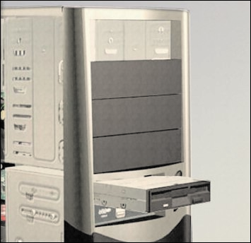

**Virtual Desktop Activity: Drives in External Bays**

System requirements for the Virtual Desktop include a minimum of 512 MB RAM and

Windows 2000 or Windows XP operating system.

Complete the optical and floppy

drive installation in the Virtual Desktop drives in the exter-

nal bays layer. Refer to the Virtual Desktop software on the CD that comes with this book.



**Lab 3.5.2: Install the Drives**

In this lab, you install the hard drive, optical drive, and floppy drive. Refer to the lab in

*IT*

*Essentials: PC Hardware and Software Lab Manual, Fourth Edition*

.

Y

ou may perform this

lab now or wait until the end of the chapter.

**Install Adapter Cards**

***Adapter cards***

are installed to add functionality to a computer. Adapter cards must be com-

patible with the expansion slot. This section focuses on the installation of three types of

adapter cards:

n

PCIe x1 NIC

n

PCI wireless NIC

n

PCIe x16 video adapter card

After completing this section, you will meet these objectives:

n

Install the NIC.

n

Install the wireless NIC.

n

Install the video adapter card.

**Install the NIC**

A

***network interface card (NIC)***

enables a computer to connect to a network. NICs use

peripheral component interface (PCI) and PCIe expansion slots on the motherboard, as

shown in Figure 3-6.

**Figure 3-6**

PCIe Network Interface Card

88

IT Essentials: PC Hardware and Software Companion Guide

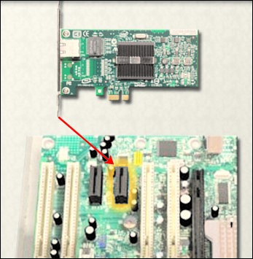

Follow these steps for NIC installation:

**Step 1.**

Remove the blank from the case where the new card will be installed so that the

port can be accessed.

**Step 2.**

Align the NIC with the appropriate expansion slot on the motherboard.

**Step 3.**

Press down gently on the NIC until the card is fully seated.

**Step 4.**

Secure the NIC PC mounting bracket to the case with the appropriate screw.

**Install the Wireless NIC**

A

wireless NIC, as shown in Figure 3-7, enables a computer to connect to a wireless net-

work. Wireless NICs use PCI and PCIe expansion slots on the motherboard. Some wireless

NICs are installed externally with a USB connector.

Follow these steps for wireless NIC installation:

**Step 1.**

Align the wireless NIC with the appropriate expansion slot on the motherboard.

**Step 2.**

Press down gently on the wireless NIC until the card is fully seated.

**Step 3.**

Secure the wireless NIC PC mounting bracket to the case with the appropriate

screw.

**Figure 3-7**

Wireless NIC

Chapter 3: Computer Assembly—Step by Step

89

**How To**

**How To**

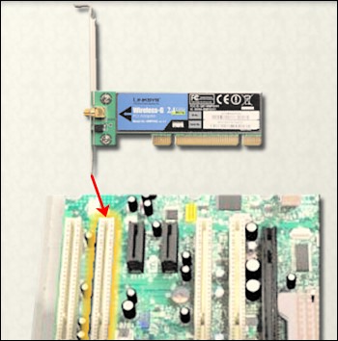

**Install the Video Adapter Card**

A

***video adapter card***

,

as shown in Figure 3-8, is the interface between a computer and a

display monitor. An upgraded video adapter card can provide better graphic capabilities for

games and graphic programs. Video adapter cards use PCI, advance graphics port (AGP),

and PCIe expansion slots on the motherboard. If the BIOS does not automatically sense the

new video card and disable the integrated one, you may need to do that manually through

BIOS settings.

**Figure 3-8**

Video Adapter Card

90

IT Essentials: PC Hardware and Software Companion Guide

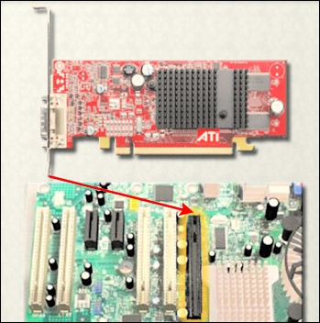

Follow these steps for video adapter card installation:

**Step 1.**

Remove the expansion slot case blank.

**Step 2.**

Align the video adapter card with the appropriate expansion slot on the mother-

board.

**Step 3.**

Press down gently on the video adapter card until the card is fully seated.

**Step 4.**

Secure the video adapter card PC mounting bracket to the case with the appro-

priate screw.

**Virtual Desktop Activity: Adapter Cards**

System requirements for the Virtual Desktop include a minimum of 512 MB RAM and

Windows 2000 or Windows XP operating system.

Complete the NIC, wireless NIC, and video adapter card installation in the Virtual Desktop

adapter card layer. Refer to the Virtual Desktop software on the CD that comes with this

book.

**Lab 3.6.3: Install Adapter Cards**

In this lab, you install the NIC, wireless NIC, and video adapter card. Refer to the lab in

*IT*

*Essentials: PC Hardware and Software Lab Manual, Fourth Edition*

.

You may perform this

lab now or wait until the end of the chapter.

**How To**



**Connect All Internal Cables**

Power cables are used to distribute electricity from the power supply to the motherboard

and other components. Data cables transmit data between the motherboard and storage

devices, such as hard drives. Additional cables connect the buttons and link lights on the

front of the computer case to the motherboard.

After completing this section, you will meet these objectives:

n

Connect the power cables.

n

Connect the data cables.

**Connect**

**the Power Cables**

Power cables are brightly colored bundles of wires that branch out from the power supply.

As the name suggests, they provide internal devices with electricity. There are several kinds

of power connectors.

Motherboard

Power Connections

Just like other components, motherboards require power to operate. The

***Advanced***

***Technology Extended (ATX)***

main power connector will have either 20 or 24 pins. The

power supply may also have a 4-pin or 6-pin Auxiliary (AUX) power connector that con-

nects to the motherboard. A 20-pin connector will work in a motherboard with a 24-pin

socket.

Follow these steps for motherboard power cable installation:

**Step 1.**

Align the 20-pin ATX power connector with the socket on the motherboard.

**Step 2.**

Gently press down on the connector until the clip clicks into place.

**Step 3.**

Align the 4-pin AUX power connector with the socket on the motherboard.

**Step 4.**

Gently press down on the connector until the clip clicks into place.

SATA Power Connectors

SATApower connectors use a 15-pin connector.

***Serial advanced technology attachment***

***(***

***SATA) power connectors***

are used to connect to hard disk drives, optical drives, or any

devices that havea

SATA

po

wer socket.

Molex Power Connectors

Hard disk drives and optical drives that do not have SATA power sockets use a Molex

power connector.

91

Chapter 3: Computer Assembly—Step by Step

**How To**

**Caution**

Do not use a Molex connector and a SATA power connector on the same drive at the same time. It

will prevent the drive from working properly.

Berg Power Connectors

The4-pin Berg power connector supplies power to a floppy drive.

Follow these steps for Berg power connector installation:

**Step 1.**

Plug the SATA power connector into the HDD.

**Step 2.**

Plug the Molex power connector into the optical drive.

**Step 3.**

Plug the 4-pin Berg power connector into the FDD.

**Step 4.**

Connect the 3-pin fan power connector into the appropriate fan header on the

motherboard, according to the motherboard manual.

**Step 5.**

Plug the additional cables from the case into the appropriate connectors accord-

ing to the motherboard manual.

**Connect the Data Cables**

Drives connect to the motherboard using data cables. The drive being connected determines

the type of data cable used. The types of data cables are PATA, SATA, and floppy disk.

PATA Data Cables

The

***parallel advanced technology attachment (PATA) data cable***

is sometimes called a rib-

bon cable because it is wide and flat. The PATA

cable can have

either 40 or 80 conductors.

APATA cable usually has three 40-pin connectors. One connector at the end of the cable

connects to the motherboard. The other two connectors connect to drives. If multiple hard

drives are installed, the master drive connects to the end connector. The slave drive connects

to the middle connector.

A

stripe on the data cable denotes the location of Pin 1. Plug the PATA cable into the drive

with the Pin 1 indicator on the cable aligned with the Pin 1 indicator on the drive connector.

The Pin 1 indicator on the drive

connector is usually closest to the power connector on the

drive. Many motherboards have two PATA drive controllers, providing support for a maxi-

mum of four PATA drives.

SATA Data Cables

The

***SATA data cable***

has a 7-pin connector. One end of the cable is connected to the moth-

erboard. The other end is connected to any

drive that has a SATA data connector.

IT Essentials: PC Hardware and Software Companion Guide

92

**How To**

**Reattach the Side Panels and Connect External**

**Cables to the Computer**

Now that all the internal components have been installed and connected to the motherboard

and power supply, you need to reattach the side panels to the computer case. The next step

is to connect the cables for all computer peripherals and the power cable.

After completing this section, you will meet these objectives:

n

Reattach the side panels to the case.

n

Connect external cables to the computer.

**Reattach the Side Panels to the Case**

Mostcomputer cases have two panels, one on each side. Some computer cases have one

three-sided cover that slides down over the case frame.

When the cover is in place, make sure that it is secured at all screw locations. Some com-

puter cases use screws that are inserted with a screwdriver. Other cases have knob-type

screws that can be tightened by hand. Tool-less cases simply “click” closed.

If you are unsure about how to remove or replace the computer case, refer to the documen-

tation or website of the manufacturer for more information.

**Caution**

Handle case parts with care. Some computer case covers have sharp or jagged edges.

**Connect**

**External Cables**

**to the Computer**

Afterthe case panels have been reattached, connect the cables to the back of the computer.

Here are some common external cable connections:

n

Monitor

n

Keyboard

n

Mouse

n

USB

n

Ethernet

n

Power

When attaching cables, ensure that they are connected to the correct locations on the com-

puter.For example, some mouse and keyboard cables use the same type of PS/2 connector.

Chapter 3: Computer Assembly—Step by Step

93

Floppy Drive Data Cables

The floppy drive data cable has a 34-pin connector. Like the PATA data cable, the floppy

drive data cable has a stripe to denote the location of Pin 1. A floppy drive cable usually

has three 34-pin connectors. One connector at the end of the cable connects to the mother-

board. The other two connectors connect to drives. If multiple floppy drives are installed,

the A: drive connects to the end connector. The B: drive connects to the middle connector.

Plug the floppy drive data cable into the drive with the Pin 1 indicator on the cable aligned

with the Pin 1 indicator on the drive connector. Motherboards have one floppy drive con-

troller, providing support for a maximum of two floppy drives.

**Note**

If Pin 1 on the floppy drive data cable is not aligned with Pin 1 on the drive connector, the floppy

dri

ve does not function. This misalignment does not damage the drive, but the drive activity light dis-

plays continuously. To fix this problem, turn off the computer and reconnect the data cable so that

Pin 1 on the cable and Pin 1 on the connector are aligned. Reboot the computer.

Follow these steps for data cable installation:

**Step 1.**

Plug the motherboard end of the PATA

cable into the motherboard socket.

**Step 2.**

Plug the connector at the far end of the PATA cable into the optical drive.

**Step 3.**

Plug one end of the SATA cable into the motherboard socket.

**Step 4.**

Plug the other end of the SATA cable into the HDD.

**Step 5.**

Plug the motherboard end of the FDD cable into the motherboard socket.

**Step 6.**

Plug the connector at the far end of the FDD cable into the floppy

drive.

**Step 7.**

Double check to make sure all cables are securely connected to the devices and

to the motherboard.

**Virtual Desktop Activity: Internal Cables**

System requirements for the Virtual Desktop include a minimum of 512 MB RAM and

Windows 2000 or Windows XP operating system.

Complete the internal cable installation in the Virtual Desktop internal cable layer. Refer to

the Virtual Desktop software on the CD that comes with this book.

**Lab 3.7.2: Install Internal Cables**

In this lab, you install internal power and data cables in the computer. Refer to the lab in

*IT*

*Essentials: PC Hardware and Software Lab Manual, Fourth Edition*

.

You may perform this

lab now or wait until the end of the chapter.

IT Essentials: PC Hardware and Software Companion Guide

94

**How To**



**Caution**

When attaching cables, never force a connection.

**Note**

Plug in the power cable after you have connected all other cables.

Follow these steps for external cable installation:

**Step 1.**

Attach the monitor cable to the video port.

**Step 2.**

Secure the cable by tightening the screws on the connector.

**Step 3.**

Plug the keyboard cable into the PS/2 keyboard port.

**Step 4.**

Plug the mouse cable into the PS/2 mouse port.

**Step 5.**

Plug the USB cable into a USB port.

**Step 6.**

Plug the network cable into the network port.

**Step 7.**

Connect the wireless antenna to the antenna connector.

**Step 8.**

Plug the power cable into the power supply.

Figure 3-9 shows all of the external cables plugged into the back of the computer.

**Figure 3-9**

All External Cables Plugged into the Back

95

Chapter 3: Computer Assembly—Step by Step

**How To**

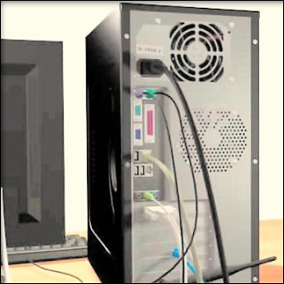

**Virtual Desktop Activity: External Cables**

System requirements for the Virtual Desktop include a minimum of 512 MB RAM and

Windows 2000 or Windows XP operating system.

Complete the external cable installation in the Virtual Desktop external cable layer. Refer to

the Virtual Desktop software on the CD that comes with this book.



**Lab 3.8.2: Complete the Computer Assembly**

In this lab, you reattach the case and connect the external cables to complete the computer

assembly. Refer to the lab in

*IT Essentials: PC Hardware and Software Lab Manual, Fourth*

*Edition*

.

You may perform this lab now or wait until the end of the chapter.

**Boot the Computer for the First Time**

When the computer is booted, the

***basic input/output system (BIOS)***

performs a check on

all of the internal components, as shown in Figure 3-10. This check is called a power-on

self test (POST).

After completing this section, you will meet these objectives:

n

Identify beep codes.

n

Describe BIOS setup.

**Figure 3-10**

BIOS

Setup Screenshot

96

IT Essentials: PC Hardware and Software Companion Guide

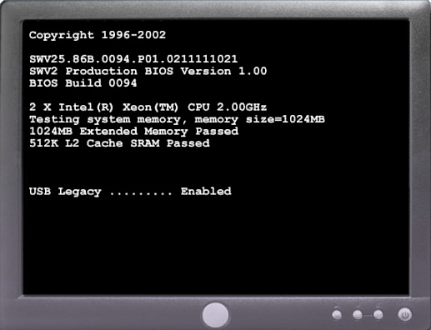

**Identify Beep Codes**

POST checks to see that all of the hardware in the computer is operating correctly. If a

device is malfunctioning, an error or a beep code alerts the technician that there is a prob-

lem. Typically,a

single beep denotes that the computer is functioning properly.

If there is a

hardware problem, the computer might emit a series of beeps. Each BIOS manufacturer

uses different codes to indicate hardware problems. Table 3-1 shows a sample chart of

***beep***

***codes***

.

The beep codes for your computer might be different. Consult the motherboard doc-

umentation to view beep codes for your computer.

**Table 3-1**

Sample Beep Codes

**Beep Code**

**Meaning**

**Cause**

1

Successfully passed POST

Passed POST

beep

2

beeps

Memory parity error

Bad memory

3

beeps

Base 64K memory failure

Bad memory

4

beeps

Timer not operational

Bad motherboard

5

beeps

Processor error

Bad processor

6

beeps

Bad CPU or motherboard

8042

gate A20 failure

7

beeps

Processor exception

Bad processor

8

beeps

Video memory error

Bad video card or memory

9

beeps

Bad BIOS

ROM checksum error

10

beeps

Bad motherboard

CMOS checksum error

beeps

11

Cache memory bad

Bad CPU or motherboard

**Describe BIOS Setup**

The BIOS contains a setup program used to configure settings for hardware devices. The

configuration data is saved to a special memory chip called a

***complementary metal-oxide***

***semiconductor (CMOS)***

.

CMOS is maintained by the battery in the computer.

If this battery

dies, all BIOS setup conf

iguration data will be lost. If this occurs, replace the battery and

reconfigure the BIOS settings.

To

enter the BIOS setup program, you must press the proper key or key sequence during

POST. Most computers use the Delete key. Your computer might use another key or combi-

nation of keys.

Figure 3-11 shows an example of a BIOS setup program.

Chapter 3: Computer Assembly—Step by Step

97

Here are some common BIOS setup menu options:

n

**Main**

:

System time, date, HDD type, and so forth

n

**Advanced**

:

Infrared port settings, parallel port settings, and so forth

n

**Security**

Password settings to setup utility

:

n

**Others**

:

Low battery alarm, system beep, and so on

n

**Boot**

:

Boot order of the computer

n

**Exit**

:

Setup utility exit

**Lab 3.9.2: Boot the Computer**

In this lab, you boot the computer and verify BIOS settings. Refer to the lab in

*IT*

*Essentials: PC Hardware and Software Lab Manual, Fourth Edition*

.

You may perform this

lab now or wait until the end of the chapter.

IT Essentials: PC Hardware and Software Companion Guide

98

**Figure 3-11**

BIOS Setup Program

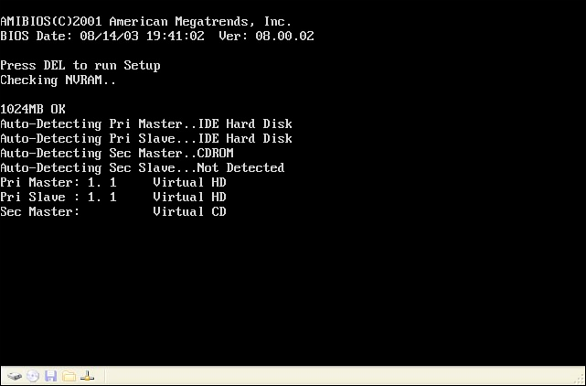

99

Chapter 3: Computer Assembly—Step by Step

**Summary**

This chapter detailed the steps used to assemble a computer and boot the system for the first

time. These are some important points to remember:

n

Computer cases come in a variety of sizes and configurations. Many of the computer’s

components must match the case’s form factor.

n

The CPU is installed on the motherboard with a heat sink/fan assembly.

n

The power supply is installed in the PC.

n

RAM is installed in RAM slots found on the motherboard.

n

Adapter cards are installed in PCI and PCIe expansion slots found on the motherboard.

n

Hard disk drives are installed in 3.5-inch drive bays located inside the case.

n

Optical drives are installed in 5.25-inch drive bays that can be accessed from outside

the case.

n

Floppy drives are installed in 3.5-inch drive bays that can be accessed from outside the

case.

n

Power supply cables are connected to all drives and the motherboard.

n

Internal data cables transfer data to all drives.

n

External cables connect peripheral devices to the computer.

n

Beep codes signify when hardware malfunctions.

n

The BIOS setup program is used to display information about the computer compo-

nents and allows the user to change system settings.

**Summary of Exercises**

This is a summary of the Labs, Worksheets, Remote Technician exercises, Class

Discussions, Virtual Desktop activities, and Virtual Laptop activities associated with this

chapter.

**Labs**

The following labs cover material from this chapter. Refer to the labs in

*IT Essentials: PC*

*Hardware*

*and Software*

*Lab Manual, Fourth Edition*

.

**Lab 3.2.0: Install the Power Supply**

**Lab 3.3.3: Install the Motherboard**

**Lab 3.5.2: Install the Dri**

**ves**

99

.qxp 8/20/10 1:37 PM Page

9781587132636_ch03

100

IT Essentials: PC Hardware and Software Companion Guide

**Lab 3.6.3: Install Adapter Cards**

**Lab 3.7.2: Install Internal Cables**

**Lab 3.8.2: Complete the Computer Assembly**

**Lab 3.9.2: Boot the Computer**

**Virtual Desktop Activities**

The following Virtual Desktop activities cover material from this chapter. Refer to the

Virtual Desktop software on the CD that comes with this book.

**Virtual Desktop Activity: Power Supply**

**V**

**irtual Desktop Activity: Motherboard**

**Virtual Desktop Activity: Internal Drives**

**Virtual Desktop Activity: Drives in External Bays**

**Virtual Desktop Activity: Adapter Cards**

**Virtual Desktop Activity: Internal Cables**

**Virtual Desktop Activity: External Cables**

**Check Your Understanding**

You can find the answers to these questions in the appendix, “Answers to Check Your

Understanding Questions.”

**1.**

A

technician is installing a new power supply in a computer. Which type of power con-

nector should be used to connect to a CD-ROM?

A.Berg

B.Mini-Molex

C.Molex

D.

20-

pin ATX connector

**2.**

A

technician is installing a new

power supply in a computer.

Which type of power con-

nector should be used to connect to an ATX motherboard?

A.Berg

B.Mini-Molex

C.Molex

D.20-pin connector



Chapter 3: Computer Assembly—Step by Step

101

**3**

.When a technician installs a new CPU, what will help maintain even contact and heat

distribution between the CPU and heat sink?

A.Silicon spray

B.Graphite paste

C.Glue

D.Thermal compound

**4.**

When installing a CPU in a ZIF socket, how should the technician align the pins to

avoid damage?

A.Pin 1 is always aligned with the corner opposite the base of the lever.

B.Pin 1 on the CPU is aligned with Pin 1 on the ZIF socket.

C.Pin 1 is aligned with the corner closest to the memory.

D.The removed corner of the CPU is always aligned with the corner opposite Pin 1.

**5.**

A

technician is installing additional memory in a computer. How can the technician

guarantee that the memory is correctly aligned?

A.The label on the memory module should always face the CPU.

B.A notch in the memory module should be aligned with a notch in the slot on the

motherboard.

C.The arrows on the memory module should be aligned with the arrows on the moth-

erboard slot.

D.All memory and motherboard slots are color-coded, with one red end and one blue

end.

**6.**

When mounting a motherboard in a computer case, what does the technician use to

prevent the motherboard from touching the bottom of the case?

A.Standoffs

B.Ground-fault isolators

C.Silicon spray

D.Grounding straps

**7.**

When installing adapter cards in a computer, how should a technician properly secure

the card?

A.

Install the card, and attach it to the expansion slot using thermal paste.

B.Install the card, and attach it to the motherboard using thermal pads.

C.Install the card, and secure it using metal retaining clips located on the expansion

slot.

D.Install the card, and secure it to the case with a screw. Or, if the case provides plas-

tic or metal clips, use them.

102

IT Essentials: PC Hardware and Software Companion Guide

**8.**

Which two connectors are used to connect external peripherals?

A.EIDE

B.Molex

C.PATA

D.PS/2

E.USB